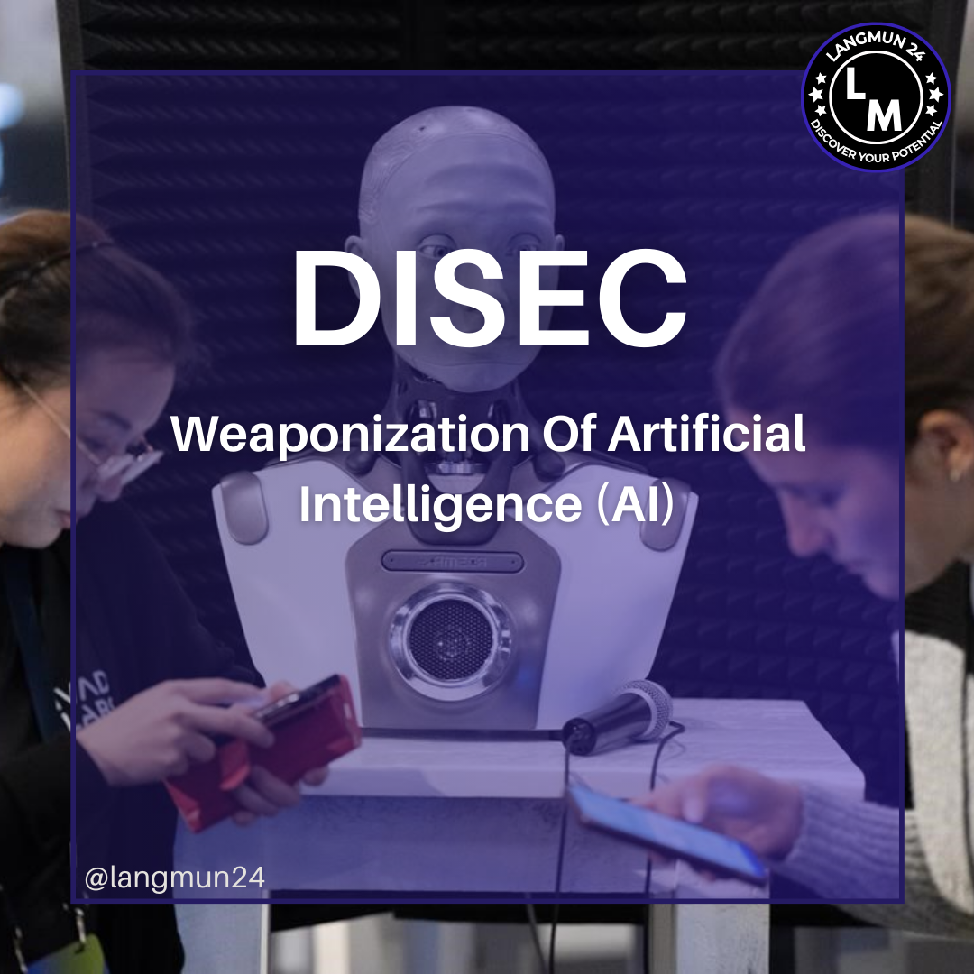

Conference: LANGMUN 24

Committee: The United Nations Disarmament and International Security Committee

Agenda Item: Weaponization of Artificial Intelligence

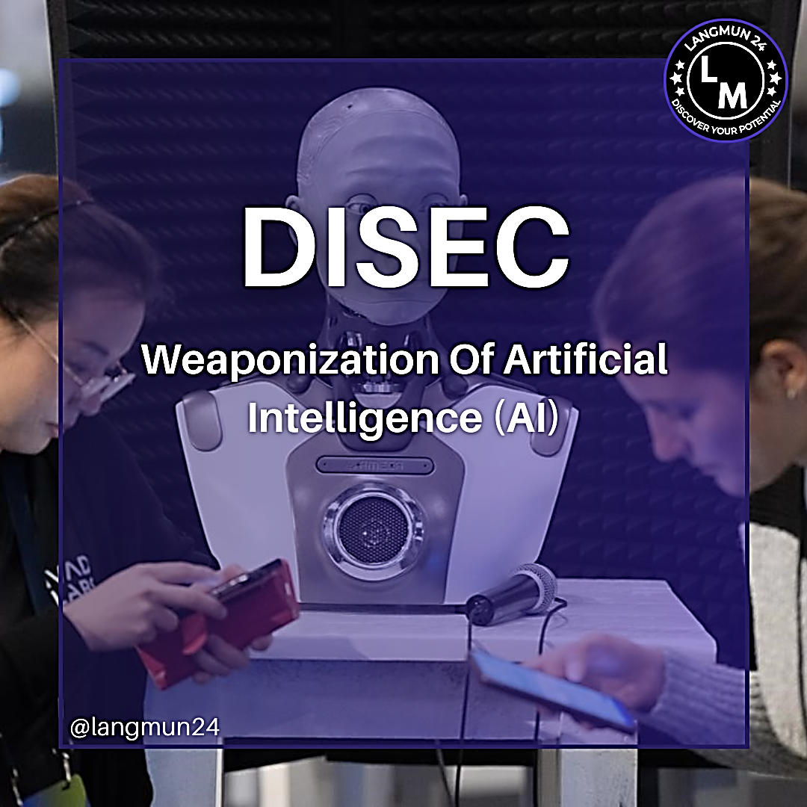

Table of Content

Letter from the Secretary General
1.0 Introduction to the Committee
1.1 Topic Overview
1.2 Key Concepts and Definitions
1.3 Historical Background
2.0 Current Situation
2.1 Key Stakeholders
2.2 Past UN Actions
3.0 Major Issues and Challenges
3.1 Possible Solutions
3.2 Questions to Consider
4.0 Bibliography

Letter From Secretary-General

Most Esteemed Delegates of LANGMUN24,

I, as the Secretary General of LANGMUN24, am delighted to welcome you to the first iteration of Lang-Up Academy Model United Nations. I am pleased to present to you the fruits of our labour, which we have been preparing for several months. My team has worked tirelessly to deliver the best of unforgettable experiences that you will see for the first time in your city.
Our aim is to facilitate competent and high-level diplomatic negotiations,fostering valuable and constructive solutions throughout the two-day duration of LANGMUN, enriched by the collective contributions of all participants. As a delegate, your preparation for the event begins here, with the study guide prepared by our dedicated members;your most honorable chairboard.
I urge you to read this study guide thoroughly and to expand your research, focusing on your assigned country. Dig deeper,ask more questions and follow the path that your search engine of choice leads you down.
To conclude my words,you have my best wishes for success and enriched debates during these two days of enjoyment. I'm looking forward to witnessing the precious contributions you will make to our conference.

Best regards,
Nisa Naz Özdoğru
Secretary General of LANGMUN24

I. Introduction to DISEC
The Disarmament and International Security Committee (DISEC) is the First Committee of the United Nations General Assembly, tasked with addressing issues related to global peace, disarmament, and international security. DISEC's mandate includes a wide range of topics, including arms control, military spending, and efforts to combat threats to international peace, including the emerging challenges posed by advanced technologies such as Artificial Intelligence (AI).

II. Topic Overview: Weaponization of AI
AI refers to the simulation of human intelligence processes by machines, particularly computer systems. These processes include learning, reasoning, and self-correction. AI has transformative potential across various sectors, including healthcare, finance, and defense. However, its application in military and security contexts, known as the weaponization of AI, raises significant ethical, legal, and security concerns.
The weaponization of AI involves developing and deploying AI technologies for military purposes, including autonomous weapons systems, enhanced surveillance capabilities, and cyber warfare. The potential for AI to be used in offensive and defensive military operations has sparked a global debate over its implications for international security, human rights, and the future of warfare.

III. Key Concepts and Definitions
- Autonomous Weapons Systems (AWS): These are weapon systems that, once activated, can select and engage targets without further human intervention. AWS includes drones, unmanned ground vehicles, and other robotic systems equipped with AI algorithms capable of making decisions in real-time.

- Cyber Warfare: The use of digital attacks, often leveraging AI, to disrupt, damage, or gain control over an adversary's information systems, infrastructure, or digital networks.

- AI in Surveillance: AI-powered surveillance systems use facial recognition, pattern recognition, and data analytics to monitor, track, and predict human behavior. While useful in counterterrorism, such systems raise significant privacy and human rights concerns.

- Ethics of AI in Warfare: The moral implications of using AI in warfare, particularly the potential loss of human oversight in life-and-death decisions, collateral damage, the risk of AI-driven escalation, and the challenges of accountability for AI-initiated actions.

IV. Historical Background
The integration of technology into military operations is not new, but the rapid advancement of AI has accelerated discussions around its implications for warfare. The concept of autonomous weapons has evolved significantly since the introduction of basic unmanned systems. Today, advanced AI technologies are being developed for complex military applications, including decision-making support, predictive analytics for strategic planning, and autonomous drones capable of executing missions without human control.
Several key milestones have shaped the debate:
- 2010s: Introduction of the first autonomous drones and AI-enhanced cyber warfare tools.
- 2017: The establishment of the UN Group of Governmental Experts (GGE) on Lethal Autonomous Weapons Systems (LAWS) under the Convention on Certain Conventional Weapons (CCW), marking the beginning of formal international discussions on the regulation of AI in warfare.
- 2020s: Growing calls for a global ban on autonomous weapons systems, driven by concerns from civil society organizations, technologists, and some member states.

V. Current Situation
As of today, the weaponization of AI remains a critical issue in international security:
- Military AI Programs: Many countries are investing heavily in AI for military purposes, including the United States, China, and Russia. These programs focus on developing AI for battlefield management, cyber defense, and autonomous weapons.
- Global Governance Challenges: The rapid pace of AI development has outstripped international regulatory frameworks, leading to a governance gap. There is currently no comprehensive international treaty specifically addressing the weaponization of AI, though efforts are being made through the CCW and other forums.
- Ethical and Humanitarian Concerns: The potential for AI to make autonomous decisions in warfare raises concerns about accountability, the potential for unintended escalation, and the risk of AI-driven warfare violating international humanitarian law.

VI. Key Stakeholders
- Major Military Powers: Countries like the United States, China, Russia and Israel are at the forefront of AI military research and development. Their positions on AI governance and regulation are crucial in shaping international policy.
- United Nations and International Organizations: The UN, through bodies like DISEC and the CCW, plays a central role in facilitating dialogue and negotiations on the regulation of AI in military contexts.
- Civil Society and Advocacy Groups: Organizations such as the Campaign to Stop Killer Robots advocate for a preemptive ban on fully autonomous weapons, highlighting the ethical risks of removing human control from life-and-death decisions.
- Private Sector and Tech Industry: Companies developing AI technologies are key players in this debate, given their role in creating the tools that could be weaponized. Their participation in global governance discussions is essential for developing effective regulations.

VII. Past UN Actions
- UN GGE on LAWS (2017-present): The Group of Governmental Experts on Lethal Autonomous Weapons Systems has been the primary forum for UN discussions on the weaponization of AI. The GGE has made some progress in identifying key issues but has not yet reached a consensus on a binding treaty.
- CCW Review Conferences: The Convention on Certain Conventional Weapons regularly reviews issues related to emerging technologies in warfare, including AI. These conferences provide a platform for states to negotiate new protocols or amendments to existing agreements.
- UN Resolutions: Several UN General Assembly resolutions have called for greater international cooperation on AI governance, ethical considerations in AI development, and the need for transparency and accountability in AI deployment.

VIII. Major Issues and Challenges
- Lack of International Consensus: There is significant disagreement among member states about how to regulate AI in military contexts. Some advocate for a total ban on autonomous weapons, while others argue for responsible development with appropriate safeguards.
- Rapid Technological Advancement: The pace of AI development makes it difficult for international regulations to keep up. This creates a risk that new AI weapons could be deployed before appropriate legal and ethical frameworks are in place.
- Accountability and Liability: Determining accountability for the actions of AI systems in warfare is a major challenge. If an AI system makes a lethal decision, it is unclear who would be held responsible—the developer, the operator, or the state deploying the system.
- Human Rights and Humanitarian Law: The use of AI in warfare raises concerns about compliance with international humanitarian law, particularly the principles of distinction, proportionality, and necessity.

IX. Possible Solutions
- International Treaty on Autonomous Weapons: A legally binding treaty could establish clear rules and restrictions on the development and use of autonomous weapons systems, potentially including a ban on certain types of AI-driven weapons.
- Ethical Guidelines and Best Practices: Developing global ethical guidelines for the use of AI in military contexts could help ensure that AI technologies are used responsibly and in line with international norms.
- Strengthening Existing Frameworks: Enhancing the role of existing international frameworks, such as the CCW, to address the challenges posed by AI weaponization could provide a more immediate solution while broader agreements are negotiated.
- Confidence-Building Measures: States could adopt confidence-building measures, such as transparency initiatives and data sharing, to reduce the risk of AI-driven conflicts and build trust in the responsible use of AI technologies.

X. Questions to Consider
- Should the international community pursue a complete ban on autonomous weapons, or are there circumstances where their use could be justified?
- How can the UN balance the need for technological innovation with the need to prevent the misuse of AI in warfare?
- What role should states, and international agencies play in the regulation of AI weaponization?
- What are the difficulties of coming up with regulations for such technologies as AI whose future uses and misuses cannot be fully foreseen?
- How can existing international laws that were signed in the past, such as the Geneva Conventions, be adapted and updated to address the unique challenges posed by AI in warfare?
- What measures can be taken and by whom or what to ensure accountability and transparency in the deployment of AI technologies in military contexts?

XI. Conclusion
The weaponization of AI is one of the most pressing challenges facing the international community today. As AI technology continues to evolve, it is crucial that DISEC and the broader UN system work together to develop effective frameworks for governing its use in military contexts. Delegates must consider the ethical, legal, and security implications of AI weaponization and strive to find a balanced approach that ensures both global security and the responsible use of technology.

XII. BİBLİOGRAPHY
Articles and Websites Killer Robots, www.stopkillerrobots.org/learn/. “Autonomous Weapons That Kill Must Be Banned, Insists UN Chief | UN News.” United Nations, United Nations, 25 Mar. 2019, news.un.org/en/sto- ry/2019/03/1035381. “Banning Autonomous Weapons Is Not the Answer.” Chatham House, 7 Dec. 2018, www.chathamhouse.org/expert/comment/banning-autonomous- weapons-notanswer?gclid=Cj0KCQjw9JzoBRDjARIsAGcdIDUtrifOd03Pf262YYIzuBvGxWj7ufqsK9S9RDtsFGDKHvRWzFMVGfsaAnWYEALw_wcB. Bendett, Samuel. “Did Russia Just Concede a Need to Regulate Military AI?” Defense One, 25 Apr. 2019, www.defenseone.com/ideas/2019/04/russian- military-finallycalling-ethics-artificial-intelligence/156553/. Blogger, A Guest. “Handful of Countries – Including the US and Russia – Ham- per Discussions to Ban Killer Robots at UN.” Future of Life Institute, a Guest Blogger Https://Futureoflife.org/Wp-Content/Uploads/2015/10/ FLI_logo-1.Png, 26 Nov. 2018, futureoflife.org/2018/11/26/handful-of-coun- triesincluding-the-us-and-russia-hamper-discussions-to-ban-killer-robots-at- un/. “China's Strategic Ambiguity and Shifting Approach to Lethal Autonomous Weapons Systems.” Lawfare, 20 Apr. 2018, www.lawfareblog.com/chinas- strategic-ambiguityand-shifting-approach-lethal-autonomous-weapons-sys- tems. Dujmovic, Jurica. “Killer Robots Are on the Way, and They're a Threat to Humanity.” MarketWatch, 29 Sept. 2018, www.marketwatch.com/story/ killer-robots-are-on-theway-and-theyre-a-threat-to-humanity-2018-09-27? si. Gayle, Damien. “UK, US and Russia among Those Opposing Killer Robot Ban.” The Guardian, Guardian News and Media, 29 Mar. 2019, www.theguardian.- com/science/2019/mar/29/uk-us-russia-opposing-killer-robot-ban-un-ai. “Home.” Autonomous Weapons Experts Meeting, reachingcriticalwill.org/ disarmament-fora/ccw/2018/laws. “Killer Robots.” Human Rights Watch, www.hrw.org/topic/armas/killer- robots. 9 Costeas-Geitonas School Model United Nations 2019 “Killer Robots: Experts Warn of 'Third Revolution in Warfare'.” BBC News, BBC, 21 Aug. 2017, www.bbc.com/news/technology-40995835. “Lethal Autonomous Weapons Systems: Recent Developments.” Lawfare, 11 Mar. 2019, www.lawfareblog.com/lethal-autonomous-weapons-systems-re- cent-developments. Liivoja, Rain. “Why It's so Hard to Reach an International Agreement on Killer Robots.” Phys.org, Phys.org, 12 Sept. 2018, phys.org/news/2018-09- hard-internationalagreement-killer-robots.html. “Slashdot.” What Will Happen When Killer Robots Get Hijacked?, hardware.slashdot.org/story/18/09/30/0442235/what-will-happen-when-killer- robots-gethijacked. United Nations Office of Geneva. “UNOG - The United Nations Office at Geneva.” Where Global Solutions Are Shaped for You | Disarmament | 2018 Group of Governmental Experts on Lethal Autonomous Weapons Systems (LAWS), www.unog.ch/80256EE600585943/(httpPages)/7C335E71DFCB29D1C1258243003E8724?OpenDocument.

